Hypervolume

Definition
# Source: AI Source: Provided by: [Data Path: Persons Table -> ID Column: 1, Name_En Column: Motasem Essam] -> From: [ChatGPT] on [7/20/2026]
Hypervolume is a generalization of volume to higher-dimensional geometry. While ordinary volume measures three-dimensional space, hypervolume measures the amount of space occupied by an object in four or more dimensions.
In simple terms:
Hypervolume extends the concept of volume beyond ordinary 3D geometry.
$$\boxed{\text{Hypervolume}=\text{Measure of Higher-Dimensional Space}}$$
For an $n$-dimensional object:
$$\boxed{\left[\text{Hypervolume}\right]=L^{n}}$$

Relationship to Other Geometric Measurements
# Source: AI Source: Provided by: [Data Path: Persons Table -> ID Column: 1, Name_En Column: Motasem Essam] -> From: [ChatGPT] on [7/20/2026]
Hypervolume fits into the dimensional hierarchy:
$$\boxed{\begin{aligned}Length→L \\ \text{Area}&→L^{2} \\ \text{Volume}&→L^{3} \\ \text{Hypervolume}&→L^{n}\end{aligned}}$$
For example:
- 1D → length
- 2D → area
- 3D → volume
- 4D and higher → hypervolume
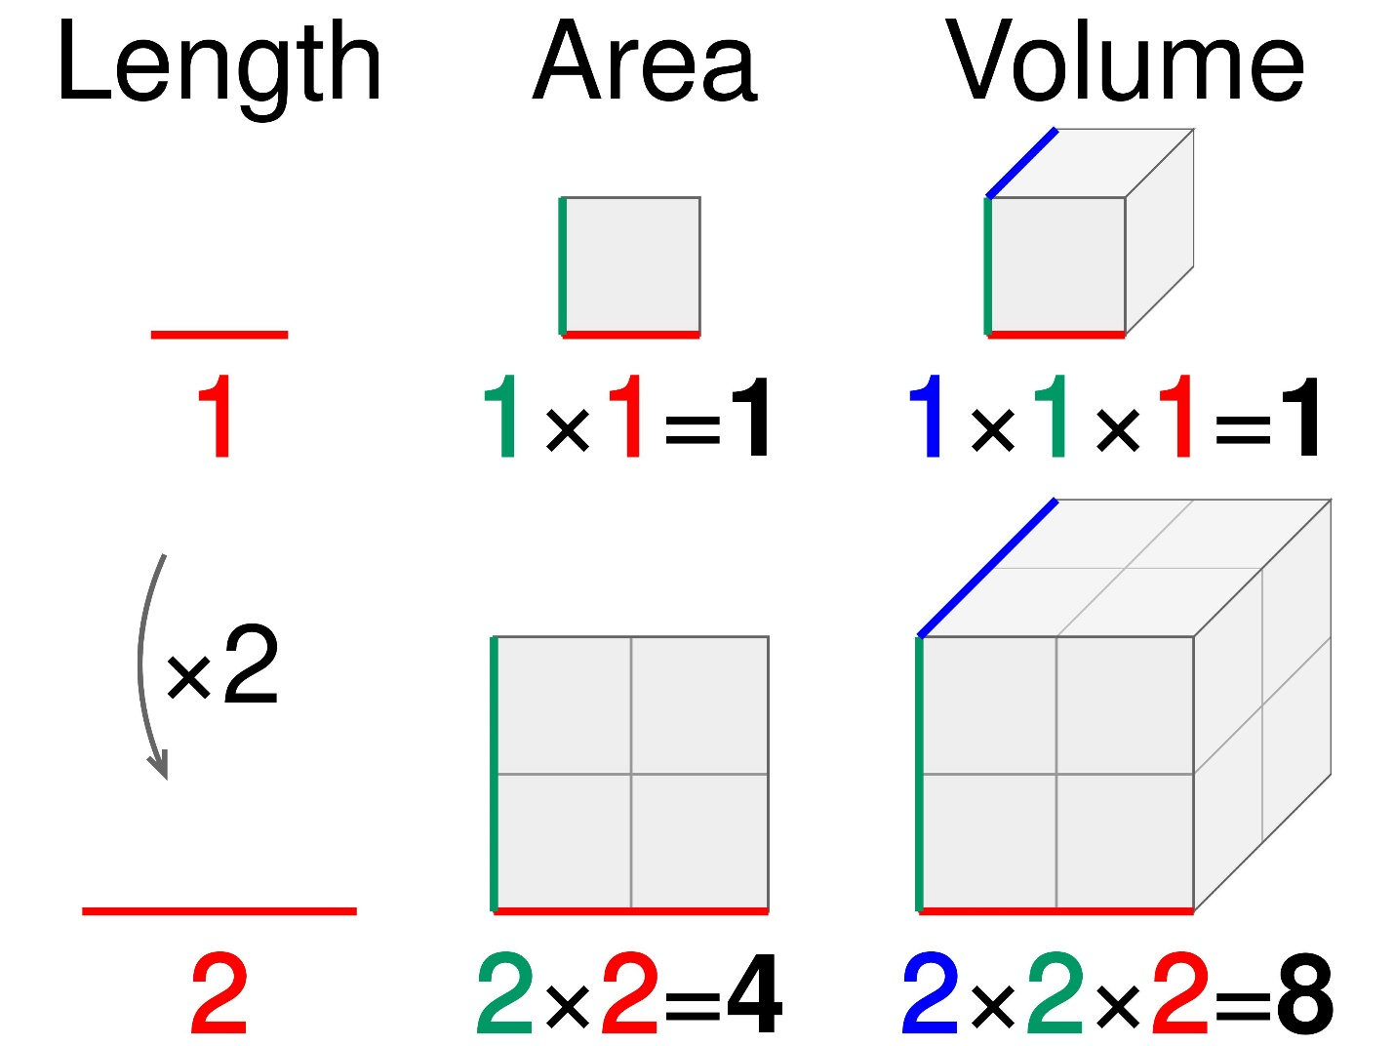
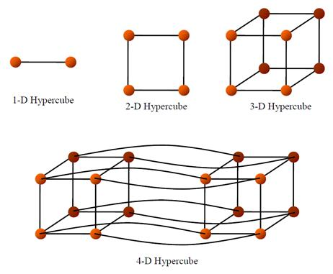
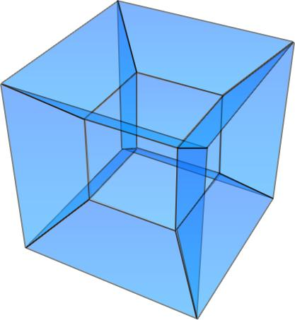
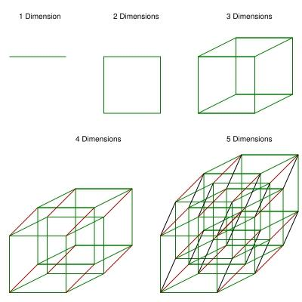
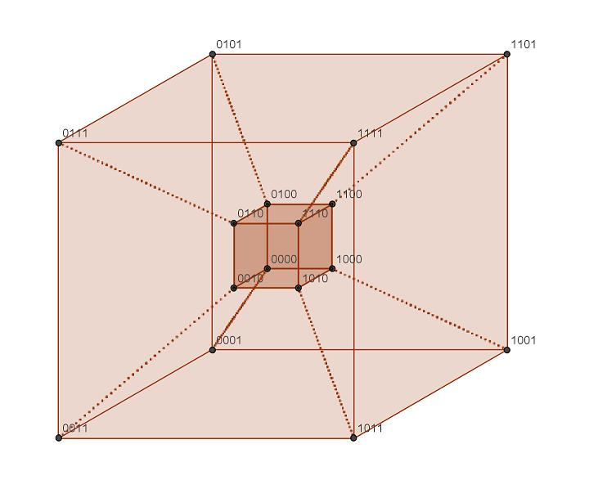
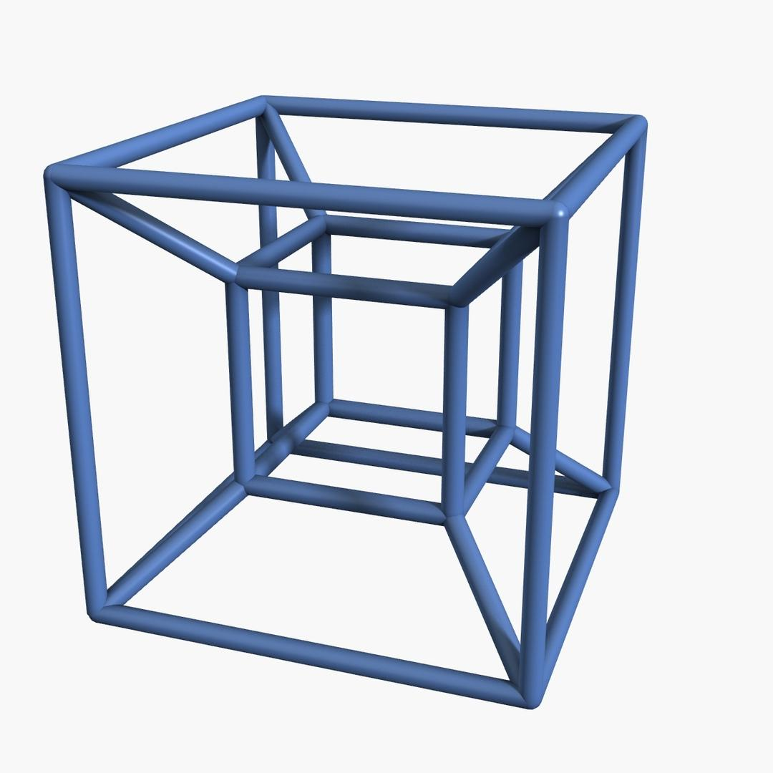

Hypervolume of a Hypercube
# Source: AI Source: Provided by: [Data Path: Persons Table -> ID Column: 1, Name_En Column: Motasem Essam] -> From: [ChatGPT] on [7/20/2026]
For an $n$-dimensional hypercube with side length $s$:
$$\boxed{V_{n}=s^{n}}$$
Examples:
2D Square
$$V_{2}=s^{2}$$
which is ordinary area.
3D Cube
$$V_{3}=s^{3}$$
which is ordinary volume.
4D Tesseract
$$V_{4}=s^{4}$$
which is 4-dimensional hypervolume.
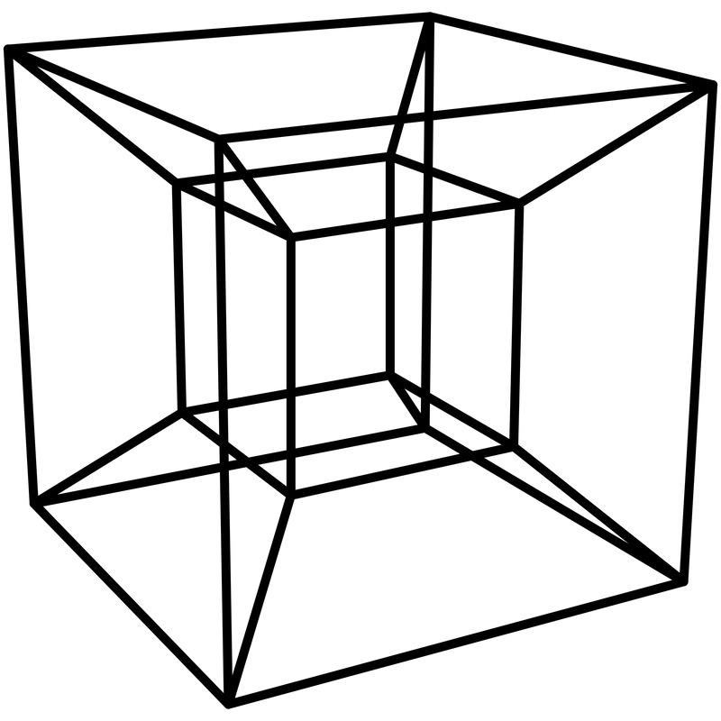
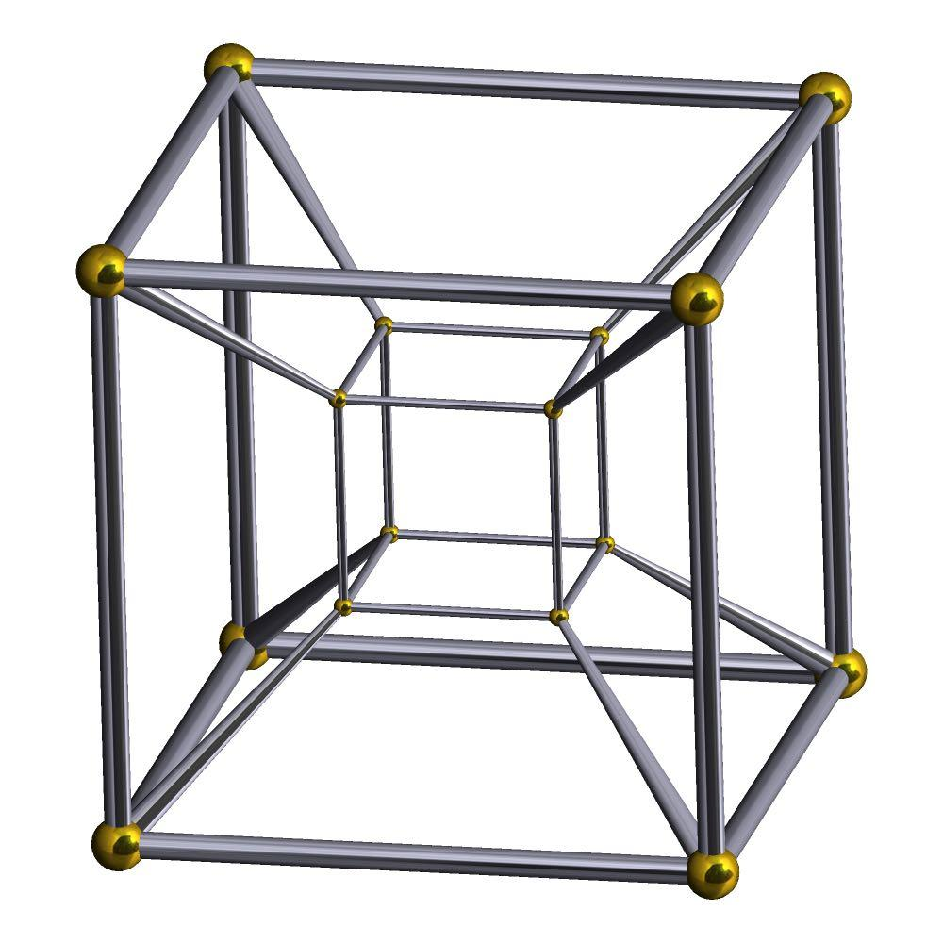

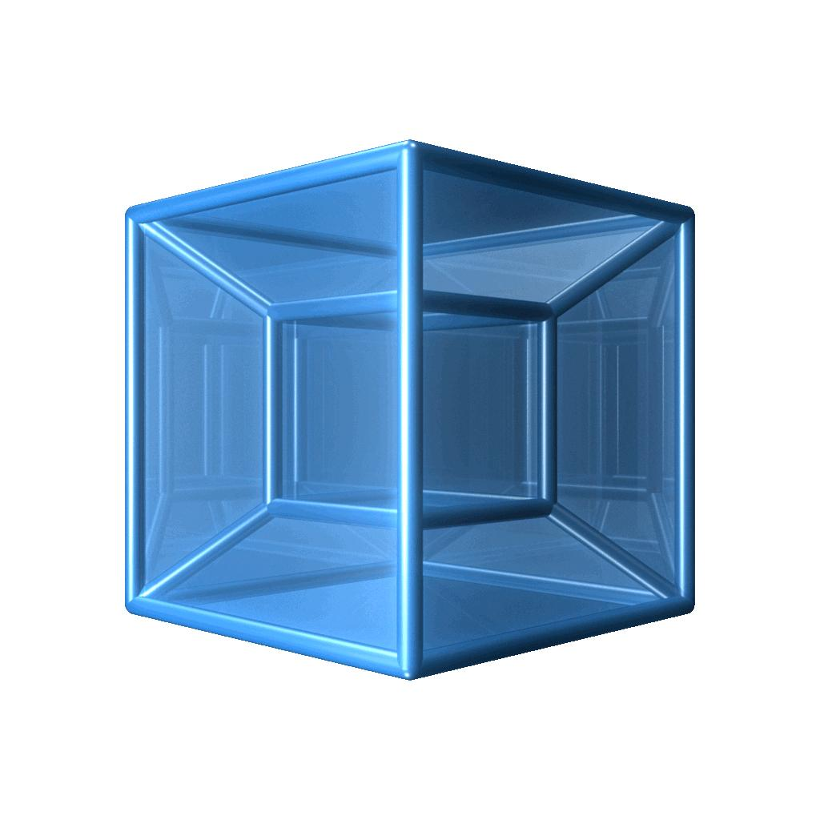

Hypervolume vs. Volume
# Source: AI Source: Provided by: [Data Path: Persons Table -> ID Column: 1, Name_En Column: Motasem Essam] -> From: [ChatGPT] on [7/20/2026]
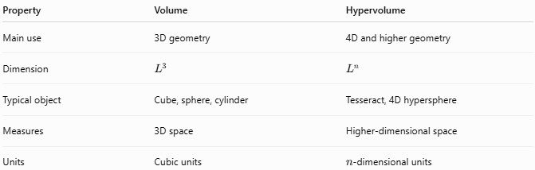
Property | Volume | Hypervolume
Main use | 3D geometry | 4D and higher geometry
Dimension | $$L^{3}$$ | $$L^{n}$$
Typical object | Cube, sphere, cylinder | Tesseract, 4D hypersphere
Measures | 3D space | Higher-dimensional space
Units | Cubic units | $n$-dimensional units
For a 4D object:
$$\boxed{\text{Hypervolume}∼L^{4}}$$

Hypervolume vs. Hyperarea
# Source: AI Source: Provided by: [Data Path: Persons Table -> ID Column: 1, Name_En Column: Motasem Essam] -> From: [ChatGPT] on [7/20/2026]
These represent different dimensional measures.
For an $n$-dimensional object:
$$\boxed{\text{Hyperarea}∼L^{n-1}}$$
while:
$$\boxed{\text{Hypervolume}∼L^{n}}$$
For a 4D object:
$$\boxed{\text{Hyperarea}∼L^{3}}$$
and:
$$\boxed{\text{Hypervolume}∼L^{4}}$$
Therefore, the hyperarea can be thought of as the boundary measure, while hypervolume measures the interior space.

Hypervolume of a Hypersphere
# Source: AI Source: Provided by: [Data Path: Persons Table -> ID Column: 1, Name_En Column: Motasem Essam] -> From: [ChatGPT] on [7/20/2026]
For an (n)-dimensional sphere (hypersphere) of radius (r), the hypervolume is:
[
$$\boxed{V_{n}\left(r\right)=\frac{π^{n/2}}{Γ\left(\frac{n}{2}+1\right)}r^{n}}$$]
where (\Gamma) is the Gamma function.
For $n=4$:
$$\boxed{V_{4}=\frac{π^{2}}{2}r^{4}}$$
This demonstrates how the familiar concept of volume can be generalized to higher dimensions.

Scaling and Hypervolume
# Source: AI Source: Provided by: [Data Path: Persons Table -> ID Column: 1, Name_En Column: Motasem Essam] -> From: [ChatGPT] on [7/20/2026]
If every linear dimension is multiplied by a scale factor $k$, hypervolume scales by:
$$\boxed{V_{\text{new}}=k^{n}V_{\text{old}}}$$
For a 4D object:
$$V_{\text{new}}=k^{4}V_{\text{old}}$$
For example, doubling every dimension gives:
$$V_{\text{new}}=2^{4}V_{\text{old}} \\ \boxed{V_{\text{new}}=16V_{\text{old}}}$$

Applications
# Source: AI Source: Provided by: [Data Path: Persons Table -> ID Column: 1, Name_En Column: Motasem Essam] -> From: [ChatGPT] on [7/20/2026]
Hypervolume is important in:
- Higher-Dimensional Geometry
- Differential Geometry
- Multivariable Calculus
- Mathematical Analysis
- Geometric Measure Theory
- Topology
- Computational Geometry
- Theoretical Physics
- Computer Graphics
- Mathematical Modeling
- Higher-Dimensional Data Analysis
- Physics of Higher-Dimensional Spaces

Advantages
# Source: AI Source: Provided by: [Data Path: Persons Table -> ID Column: 1, Name_En Column: Motasem Essam] -> From: [ChatGPT] on [7/20/2026]
Understanding hypervolume helps to:
- Extend volume concepts to four or more dimensions.
- Measure higher-dimensional regions.
- Analyze higher-dimensional geometric objects.
- Support mathematical modeling of multidimensional spaces.
- Connect geometry with multivariable calculus.
- Support theoretical physics and higher-dimensional mathematical models.
- Provide a framework for studying hyperspheres, hypercubes, and other higher-dimensional bodies.

Limitations
# Source: AI Source: Provided by: [Data Path: Persons Table -> ID Column: 1, Name_En Column: Motasem Essam] -> From: [ChatGPT] on [7/20/2026]
Hypervolume:
- Is primarily a higher-dimensional mathematical concept.
- Is difficult to visualize directly beyond three dimensions.
- Requires knowledge of higher-dimensional geometry.
- Depends on the dimension (n) of the object.
- Is not normally needed in elementary three-dimensional geometry.
- May require advanced mathematical tools such as the Gamma function for general formulas.

Key Points
# Source: AI Source: Provided by: [Data Path: Persons Table -> ID Column: 1, Name_En Column: Motasem Essam] -> From: [ChatGPT] on [7/20/2026]
$$\boxed{\text{Hypervolume}=\text{Measure of Higher-Dimensional Space}}$$
Hypervolume:
- Generalizes ordinary volume.
- Applies naturally to 4D and higher-dimensional objects.
- Has dimensional form $L^{n}$.
- Measures the interior of an $n$-dimensional region.
- Is related to hyperarea, which measures its boundary.
- Includes concepts such as tesseracts and hyperspheres.

Conclusion
# Source: AI Source: Provided by: [Data Path: Persons Table -> ID Column: 1, Name_En Column: Motasem Essam] -> From: [ChatGPT] on [7/20/2026]
Hypervolume is the higher-dimensional generalization of volume. It measures the amount of space occupied by an object in four or more dimensions. It extends the familiar sequence:
$$\boxed{\text{Length}→\text{Area}→\text{Volume}→\text{Hypervolume}}$$
where the corresponding dimensions are:
$$\boxed{L, L^{2}, L^{3}, L^{n}}$$
Hypervolume is therefore mainly used in higher-dimensional geometry, advanced mathematics, computational geometry, and theoretical physics.

